Reexam 2021

Problem 1
- There are 4 strategies
Where the ”|” means conditioned on observing signal
This gives 4 possible combinations
$$\left(B\left|D,B\right|DD\right),\left(B\left|D,DB\right|DD\right),\left(DB\left|D,DB\right|DD\right),(DB\left|D,B\right|DD)$$
- I write it up in matrix form
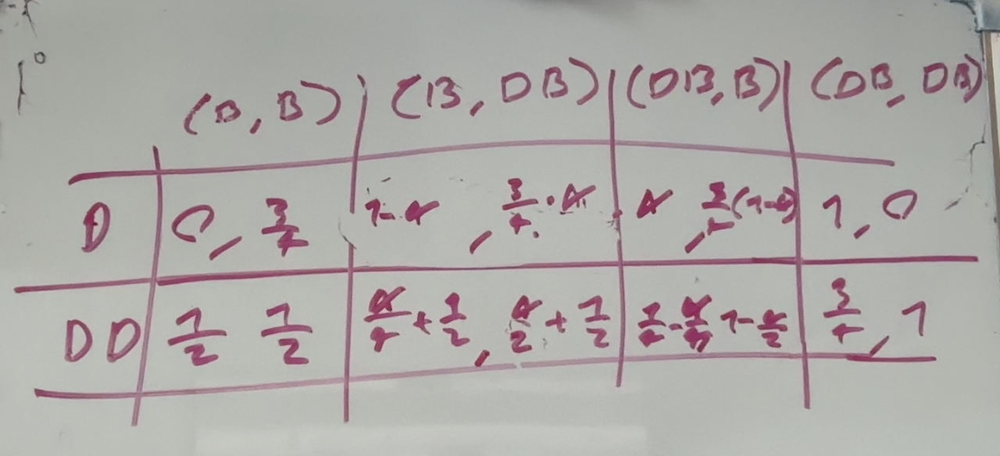

Depending on A there the 2 middle ones dominate(weakly) if $α=1 or α=0$

$$\left(B\left|D,DB\right|DD\right) (DB\left|D,B\right|DD)$$
First one dominates when the intellegence is always correct the other when the intellegens is always wrong
C)

Problem 2
A)
(Three,two)
Then Y plays M,V
On the $X_{B}$ state X prefers to play Three and get 15>0 utility thus this is not an EQ

(two,three)
Y must play F,F
In the B state X prefers to play two and get 20 >15 utility

(two,two)
In the two state Y prefers to play f since $u\left(f | two\right)=\frac{1}{2}·20=10>7.5=u(v|two)$
For this to be an EQ
We need Y’s best action to be F otherwise X will have incentive to deviate in either the B or A states
$$u\left(F | three\right)=5·μ_{3}+\left(1-μ_{3}\right)15$$
$$u\left(M | three\right)=μ_{3}·16+\left(1-μ_{3}\right)·6$$
$$u\left(V | three\right)=10$$
$$5·μ_{3}+\left(1-μ_{3}\right)15≥10$$
$⇕$
$$μ_{3}≤0,5$$
$$μ_{3}·16+\left(1-μ_{3}\right)·6≤5·μ_{3}+\left(1-μ_{3}\right)15$$
$⇕$
$$μ_{3}≤0,45$$
For $μ_{3}≤0.45$
(two,two) (F,f) is a pooling EQ

(three,three):
Y will play M if three is played since
$$u\left(M | three\right)=11>u\left(F | three\right)=10=u\left(V | three\right)$$
X will always deviate either in A or B
If Y plays f in two X deviates in state A from three to to getting 20>16 utility
If Y plays V in two X will deviate in B from three to 2 getting 15>6 utility
Thun not an EQ

The only eq then is $(two,two)(F,f)$
With $μ_{3}≤0.45,μ_{2}=\frac{1}{2}$

B. this EQ does survive the intuitive criterion
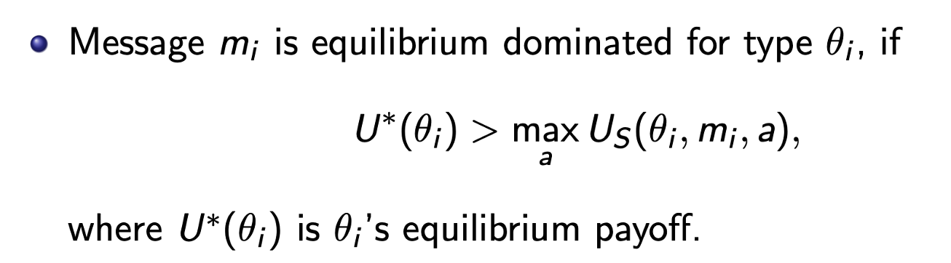
Since no message is dominated for any type
(three,M) is better for type A
(three,V) is better for type B
Since no meassage is EQ dominated we deont need to asign anything probability 0 and thus the EQ survives

Problem 3
$$Π=p·q-t$$
$$u\left(t,q,θ\right)=t-θ·q^{2}$$
$$θ_{L}>θ_{H}>0$$

a)
$$\max_{t_{H},t_{L},q_{H},q_{L}}{λ\left(p·q_{H}-t_{H}\right)+\left(1-λ\right)\left(pq_{L}-t_{L}\right)}$$
$$s.t$$
$$t_{H}-θ_{H}·q_{H}^{2}≥0$$
$$t_{L}-θ_{L}·q_{L}^{2}≥0$$
Both constraints must be binding otherwise simply lower t_i

Thus unconstrained maximisation
$Skriv ligningen her.$
$$\max_{q_{H},q_{L}}{λ\left(p·q_{H}-θ_{H}·q_{H}^{2}\right)+\left(1-λ\right)\left(pq_{L}-θ_{L}·q_{L}^{2}\right)=Π}$$
$$\frac{∂Π}{∂q_{H}}=λ\left(p-2θ_{H}q_{H}\right)=0⇔q_{H}=\frac{p}{2θ_{H}}$$

$$\frac{∂Π}{∂q_{L}}=(1-λ)\left(p-2θ_{L}q_{L}\right)=0⇔q_{L}=\frac{p}{2θ_{L}}$$
$$t_{H}=θ_{H}·{\frac{p}{2θ_{H}}}^{2}=\frac{p^{2}}{θ_{H}4}$$
$$t_{L}=\frac{p^{2}}{θ_{L}4}$$

B.
$$q_{H}=\frac{p}{2θ_{H}}>\frac{p}{2θ_{L}}=q_{L}$$
The worker type who has lower disutility form production, produces more for the firm whch makes sense
The solution is Pareto efficient
To increase worker utility we need lower q or higher t which leads to lower profit for the firm
To increase profits we need the exact opposit, thus the solution is PE

C.
We need incentive compatability
$$0=t_{H}-θ_{H}·q_{H}^{2}≥t_{L}-θ_{H}·q_{L}^{2}$$
$$t_{L}-θ_{H}·q_{L}^{2}=\frac{p^{2}}{θ_{L}4}-θ_{H}\frac{p^{2}}{4θ_{L}^{2}}=\frac{p^{2}}{θ_{L}4}\left(1-\frac{θ_{H}}{θ_{L}}\right)>0$$
Since $θ_{H}<θ_{L}$

no the solution is not implimentable since H type prefers L’s contract

D.
$$\max_{t_{H},t_{L},q_{H},q_{L}}{λ\left(p·q_{H}-t_{H}\right)+\left(1-λ\right)\left(pq_{L}-t_{L}\right)}$$
$$s.t$$
$$\begin{aligned}t_{H}-θ_{H}·q_{H}^{2}≥0\#PCH\end{aligned}$$
$$\begin{aligned}t_{L}-θ_{L}·q_{L}^{2}≥0\#\left(PCL\right)\end{aligned}$$
$$\begin{aligned}t_{H}-θ_{H}·q_{H}^{2}≥t_{L}-θ_{H}·q_{L}^{2}\#\left(ICH\right)\end{aligned}$$
$$\begin{aligned}t_{L}-θ_{L}·q_{L}^{2}≥t_{H}-θ_{L}·q_{H}^{2}\#\left(ICL\right)\end{aligned}$$

E.
PCH is slack since PCL+ICH imply PCH

$$\begin{aligned}t_{L}-θ_{L}·q_{L}^{2}≥0\#\left(PCL\right)\end{aligned}$$
$$\begin{aligned}t_{H}-θ_{H}·q_{H}^{2}≥t_{L}-θ_{H}·q_{L}^{2}\#\left(ICH\right)\end{aligned}$$
$$\begin{aligned}t_{L}-θ_{L}·q_{L}^{2}≥t_{H}-θ_{L}·q_{H}^{2}\#\left(ICL\right)\end{aligned}$$
ICH +ICL imply
$$t_{H}-θ_{H}·q_{H}^{2}≥t_{L}-θ_{H}·q_{L}^{2}⇔t_{H}-t_{L}≥θ_{H}·(q_{H}^{2}-q_{L}^{2})$$

$$t_{L}-θ_{L}·q_{L}^{2}≥t_{H}-θ_{L}·q_{H}^{2}⇔θ_{L}\left(q_{H}^{2}-q_{L}^{2}\right)≥t_{H}-t_{L}$$
Together
$$θ_{L}\left(q_{H}^{2}-q_{L}^{2}\right)≥t_{H}-t_{L}≥θ_{H}·(q_{H}^{2}-q_{L}^{2})$$
This is only true if
$$q_{H}^{2}≥q_{L}^{2},t_{H}≥t_{L}$$
ICH will bind:
Otherwise simply decrease t_H increasing profit not violating any inequalities
$$\begin{aligned}t_{L}-θ_{L}·q_{L}^{2}≥0\#\left(PCL\right)\end{aligned}$$
$$\begin{aligned}t_{H}-θ_{H}·q_{H}^{2}=t_{L}-θ_{H}·q_{L}^{2}\#\left(ICH\right)\end{aligned}$$
$$\begin{aligned}t_{L}-θ_{L}·q_{L}^{2}≥t_{H}-θ_{L}·q_{H}^{2}\#\left(ICL\right)\end{aligned}$$

$$t_{H}-θ_{H}·q_{H}^{2}=t_{L}-θ_{H}·q_{L}^{2}⇔t_{H}-t_{L}=θ_{H}\left(q_{L}^{2}-q_{H}^{2}\right)≤θ_{L}\left(q_{L}^{2}-q_{H}^{2}\right)$$
$$t_{H}-t_{L}≤θ_{L}\left(q_{L}^{2}-q_{H}^{2}\right)⇔t_{H}-θ_{L}·q_{H}^{2}≤t_{L}-θ_{L}·q_{L}^{2}=ICL$$
Thus ICL is slack

And these constraints are remaining
$$\begin{aligned}t_{L}-θ_{L}·q_{L}^{2}≥0\#\left(PCL\right)\end{aligned}$$
$$\begin{aligned}t_{H}-θ_{H}·q_{H}^{2}=t_{L}-θ_{H}·q_{L}^{2}\#\left(ICH\right)\end{aligned}$$
PCL will bind
Otherwise decrease t_h and t_l by the same epsilon

Giving

These 2 are binding
$$\begin{aligned}t_{L}-θ_{L}·q_{L}^{2}=0\#\left(PCL\right)\end{aligned}$$
$$\begin{aligned}t_{H}-θ_{H}·q_{H}^{2}=t_{L}-θ_{H}·q_{L}^{2}\#\left(ICH\right)\end{aligned}$$
While the others are slack

F.
To solve i plug in and do unconstrained optimization
$$t_{L}-θ_{L}·q_{L}^{2}=0⇔t_{L}=θ_{L}·q_{L}^{2}$$
$$t_{H}-θ_{H}·q_{H}^{2}=t_{L}-θ_{H}·q_{L}^{2}=θ_{L}·q_{L}^{2}-θ_{H}·q_{L}^{2}$$
$$t_{H}-θ_{H}·q_{H}^{2}=θ_{L}·q_{L}^{2}-θ_{H}·q_{L}^{2}$$
$⇕$ Ligningen løses for t_H vha. WordMat.
$$t_{H}=q_{L}^{2}·θ_{L}+\left(q_{H}^{2}-q_{L}^{2}\right)·θ_{H}$$

I plug in and maximize
$$\max_{q_{H},q_{L}}{λ\left(p·q_{H}-(q_{L}^{2}·θ_{L}+\left(q_{H}^{2}-q_{L}^{2}\right)·θ_{H})\right)+\left(1-λ\right)\left(pq_{L}-θ_{L}·q_{L}^{2}\right)=Π}$$
$$\frac{∂Π}{∂q_{H}}=λ·(p-2θ_{H}·q_{H})=0$$
$$⇔q_{H}=\frac{p}{2θ_{H}}$$
$$\frac{∂Π}{∂q_{L}}=λ\left(-2θ_{L}q_{L}+2θ_{H}q_{L}\right)+\left(1-λ\right)\left(p-2θ_{L}·2q_{L}\right)=0$$
$$λ\left(-2θ_{L}q_{L}+2θ_{H}q_{L}\right)+\left(1-λ\right)\left(p-2θ_{L}·q_{L}\right)$$
$$=λ·2θ_{H}q_{L}+\left(1-λ\right)·p-2θ_{L}·q_{L}=0$$
$$⇔\left(1-λ\right)·p=2θ_{L}·q_{L}-λ·2θ_{H}q_{L}=q_{L}2·\left(θ_{L}-λθ_{H}\right)⇔q_{L}=\frac{\left(1-λ\right)p}{2·\left(θ_{L}-λθ_{H}\right) }$$

g.
$q_{H}$ is the same which is known as the ”no distortion at the top” since wo only need to adjust the Low contract such that H dosen choose it (ptobably also ending up in a slightly higher wage since PCH isent binding
$$q_{L}^{SB}=\frac{\left(1-λ\right)p}{2·\left(θ_{L}-λθ_{H}\right) }≤\frac{\left(1-λ\right)p}{2·\left(θ_{L}-λθ_{L}\right) }=\frac{p}{2θ_{L}}=q_{L}^{FB}$$
For $λ∈(0,1)$ the inequlity is strict meaning that in the SB L produces less than in the first best

Problem 4

$$C_{T1}\left(r\right)=\frac{1}{2}r^{2}$$
$$C_{T2}\left(r\right)=\frac{3}{4}r^{2}$$
$$V_{T1}\left(r\right)=4r$$
$$V_{T2}\left(r\right)=2r$$
A buyer has utility
$$π=v_{i}-p$$
And the seller has
$$u_{i}\left(p,r\right)=p-c_{i}(y)$$

A.
In a seperating EQ we must have
Since we are in a competitve market $Π=0⇔p=v_{i}(r)$
A seller who has a type I car must prefer the contract made for his/her type
Each type of seller must have positive utility in selling the car (in this case they get to maximize)

$$\begin{aligned}4r_{1}-\frac{1}{2}r_{1}^{2}≥2r_{2}-\frac{1}{2}r_{2}^{2}\#IC1\end{aligned}$$

$$\begin{aligned}2r_{2}-\frac{3}{4}r_{2}^{2}≥4r_{1}-\frac{3}{4}r_{1}^{2}\#IC2\end{aligned}$$
B. i maximize within each to show that it is prefered

In this market the seller has the power to maximize utility

For type 1 car
low value:
$$\max_{r}{2r-\frac{1}{2}r^{2}=U}$$
$$\frac{∂U}{∂r}=2-r=0⇔r=2$$
Giving utility $4-2=2$ and is valid

For high value
$$\max_{r}{4r-\frac{1}{2}r^{2}=U}$$
$$\frac{∂U}{∂r}=4-r=0⇔r=4<5$$
We need the closest valid value being $r_{H}=5$
With utility
$$20-12.5=7,5>2$$
Thus this is the prefered value

Type 2 car:
Low value
$$\max_{r}{2r-\frac{3}{4}r^{2}=U}$$
$$\frac{∂U}{∂r}=2-\frac{3}{2}r=0⇔r_{2}=\frac{4}{3}$$
Giving utility
$\frac{8}{3}-\frac{4}{3}=\frac{4}{3}$ and is valid in terms of the price function

High value:
$$\max_{r}{4r-\frac{3}{4}r^{2}=U}$$
$$\frac{∂U}{∂r}=4-\frac{3}{2}r=0⇔r=\frac{8}{3}<7$$
Which is not valid since the utility is a parabola the highest possible utility is then the ”edge” value
$$r_{2}=5$$
Giving utility
$$20-\frac{3}{4}·25=1,25<\frac{4}{3}$$
Thus
$$r_{2}=\frac{4}{3}$$
Is prefered
And we have a sperating EQ

C.
We still need $E\left[Π\right]=0⇔p=E\left[v\left(r\right)\right]=3r⇒θ=3$
For this to be a pooling EQ we need
$$r_{1}=r_{2}$$

Maximering over begge omårder for begge parter skal have fælles maximum i
Jeg maximerer for type 1 og sætter cutoff lige der hvor han har maximum mon ikke at opgaven er designet efter at det ikke er alt for besværligt
$$\max_{r}{3r-\frac{1}{2}r^{2}}$$
$$\frac{∂U}{∂r}=3-r=0⇔r_{H}=3$$
Giver utility $9-4.5=4.5$
Jeg tjekker om han har max utility her
$$\max_{r}{2r-\frac{1}{2}r^{2}}$$
$$\frac{∂U}{∂r}=2-r=0⇔r_{H}=2$$
Giver utility $4-2=2<4.5$
Da foretrækker han at lægge sig selv på præcis på cutoff som vi ligger
$$\overline{r}=3$$

Vi tjekker om ikke type 2 også er glad for den kontrakt
Maximerer over høj værdi
$$\max_{r}{3r-\frac{3}{4}r^{2}}$$
$$\frac{∂U}{∂r}=3-\frac{3}{2}r=0⇔r_{H}=2<3$$
Da tviges vi til cutoff
$$r_{2}=3$$
Giver utility
$$9-\frac{3}{4}·9=2,25$$
Maximerer for lav værdi
$$\max_{r}{2r-\frac{3}{4}r^{2}}$$
$$\frac{∂U}{∂r}=2-\frac{3}{2}r=0⇔r_{H}=\frac{4}{3}$$
Som er validt
Som giver utility
$$\frac{8}{3}-\frac{4}{3}=\frac{4}{3}<2.25$$
Da foretrækker han pooling EQ
Med $θ=3,\overline{r}=3$

D. in the Pooling EQ we have belief that the car is of high value
$$μ\left(r\right)=\left\{\begin{aligned}0 for r<\overline{r} \\ \frac{1}{2} for r≥\overline{r}\end{aligned}\right.$$
These are maybe a little unreasonable as there are levels of r where the low value car has negative utility ad thus it makes no sense to repair that much for the low value Car
In the esperating:

$$μ\left(r\right)=\left\{\begin{aligned}0 for r<\overline{r} \\ 1 for r≥\overline{r}\end{aligned}\right.$$

